Welcome Club
May 21st 2021~ 3:30pm-4:30pm

Character lesson of the month:

Citizenship- My Community

- I’m an important part of my community!

3:30-3:35

Introduction to Welcome Club - (Coach Colin)
-Build friendships
-Help each other
-Discuss problems and issues with coaches and students
-Have fun!
*Review Welcome club’s foundation for how we treat each other: Treat others the way you want to be treated.

-Transition- (Coach DeVon) “Ok let’s have the coaches introduce themselves and show us your favorite picture!”
3:35-3:45

Introduction of Coaches- We will take turns sharing our name and hold up your favorite picture.

-Transition- (Coach Amy) “Now I want to introduce our lesson for today.”

Introduction of Character Lesson- “Today we are going to talk about citizenship.
-Transition- (Coach Megan) “Let’s get into our breakout rooms and we can start with a game! Everyone make sure you have your Welcome Club bag, crayons and glue stick.”

3:45-3:55

- Coaches, start your group time by having each student introduce himself or herself and share what temperature they feel like today. Next, you will need to explain the rules of the game. Assistant coaches are encouraged to participate.

ICEBREAKERS - Zoom Out
Directions: One coach will need to share their screen and play one of the videos below. If time allows, continue with game on second video or play again at end of Club. No need to share sound as game only consists of pictures. Students will guess what picture is shown. Pictures are zoomed in and consecutively zoom out. Pictures are timed and have 5 shots/images, the 5th being the whole picture. Start with awarding 5 points on the 1st image which is the hardest most zoomed in then go down to 4, 3, 2, and finally 1 point for whole image. There are 10 rounds.
https://video.link/w/momwc
https://video.link/w/gjmwc

-Transition- (coaches) “Everyone get out your craft from your goody bag and let’s get right into talking about our community”.

3:55-4:30 Craft and Lesson- Your Community
Supplies: paper circles, colors/crayons
Coaches Note- We are highlighting student’s different communities and how they fit into those communities. While leading the craft ask leading questions to get students thinking about their home, street/neighborhood, and their school. We want to communicate how happy we are that we get to be a part of a community with them and it wouldn’t be complete without them. Example questions below.

Coaches: “Open up the circles wrapped in plastic. There are 6 circles, 1 house and a blue strip of paper. We are going to make a craft all about our community. Lets start with the house. Last Club we talked about how family is the most special community we have. Everyone get out your colors and let’s color in the houses first. Next, find the smallest circle with the world “My Street” on it. Draw a picture of a street sign with the name of your street on it. Marconi Ave., El Camino, Duckhorn Now find the next circle with the words “My City or Town” and draw a picture of the city you live in. You can draw shops, houses, or a park. What is the name of our city? Sacramento or Carmichael Now, lets get the next circle out; it says “My State”. What is the name of our State? California Draw a picture of California. Next is the circle with “My Country” written on it. Color the country you live in red. What country are we living in? Some students may want to reference their home countries. Suggest they draw the country on the side or color the USA in their home country’s flag colors. Now, get the circle with “My Continent” on it. Color the continent you live on in green. Some students will want to reference their home countries or continent. Suggest they color that blue or their favorite color. And now last circle, “My Planet”. What is the name of our planet? Earth Color the planet you live on blue.
Great job everyone! Now we are going to glue the circles and the house to the blue strip of paper. First, you need to fold the bottom of all the circles and the house toward the front.
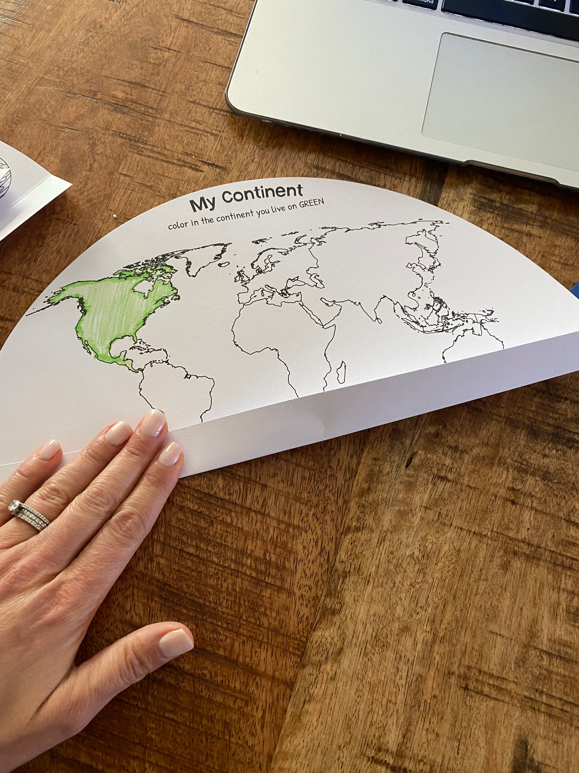

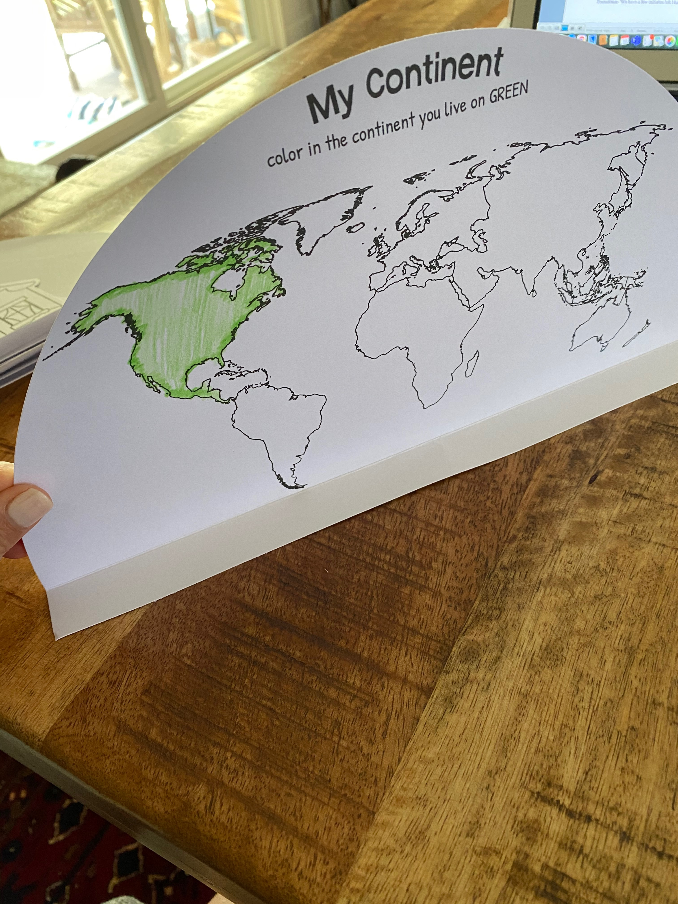

Next, put glue on the biggest circle “My Planet” on the bottom fold to attach it to the blue strip of paper. Then glue the “My Continent” down on top. Keep going from biggest to smallest ending with your house.
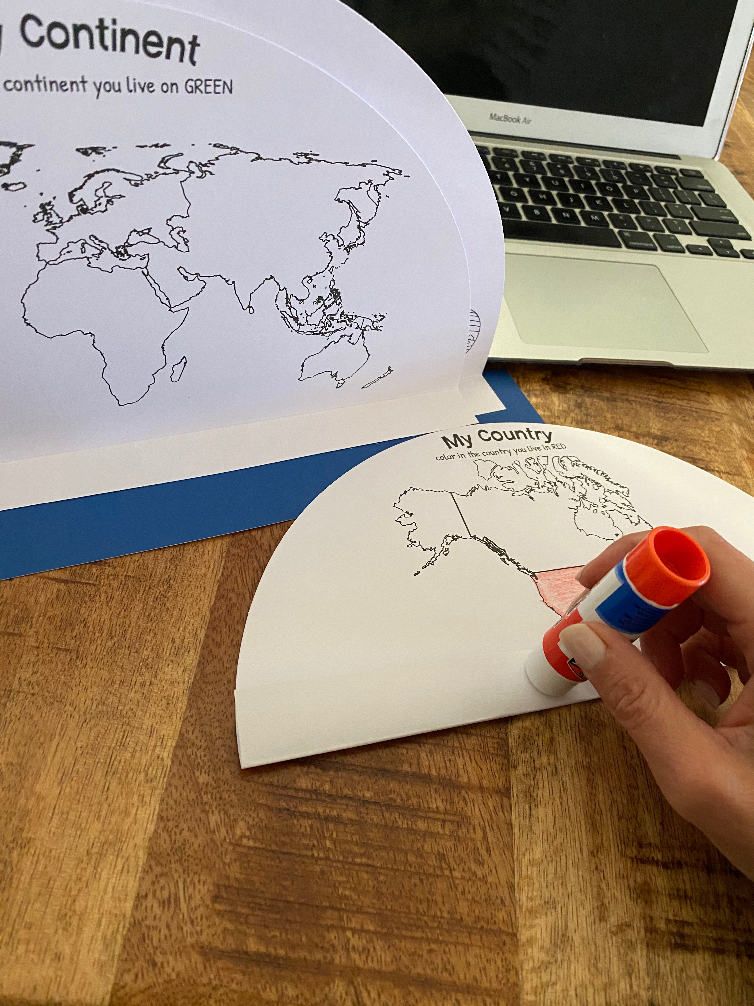
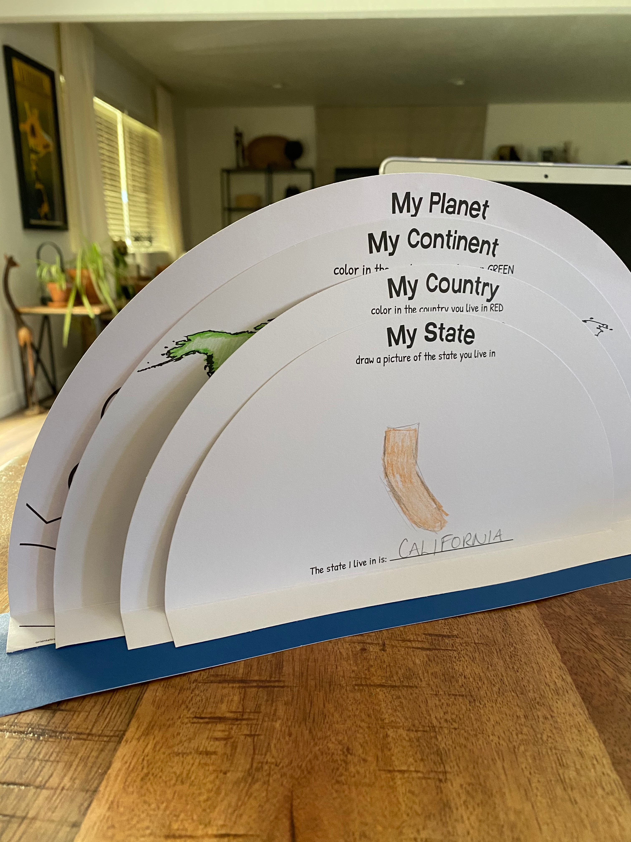
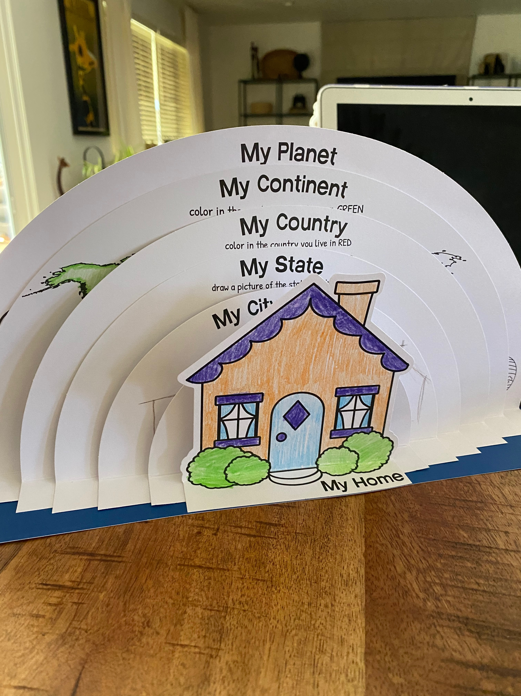

Coaches Note- While going over each circle, ask students questions about each subject. Example- “My House” what color is your house that you live in now? What color would you paint your house? Who lives in your house with you? What is a popular color to paint houses in your home country? “My City” what do you like about the city you live in? What will you draw on your circle from your city? Where do you feel most yourself? Who do you like to see when you walk around your neighborhood? What does it look like to be a part of a community? What does it feel like to be welcomed into a community/school? How can we be more welcoming to others?

*If time allows, students also have a poster of community helpers. On this poster they can choose a community helper to learn about and highlight.
Doctors, nurses, chefs, bakers, astronauts, teachers, dentists, mail carriers, bus drivers, coaches, fishermen, plumbers, firefighters, farmers, librarians, and volunteers.
Transition- “We have a few minutes left I have some funny questions for you.”
Conversation starters and fun question ideas-

- Would you rather be able to speak every language on earth or communicate with aliens?
- Would you rather be able to understand what animals are saying or have the ability to be invisible?
- Would you rather be a superhero or an astronaut?
- Would you rather make your dreams come true or make other people’s dreams come true?
- Would you rather be able meet your favorite book character or meet someone famous from history?
- Would you rather be able to read people’s minds or heal people’s bodies?
- Would you rather be able to slide down rainbows or jump on the clouds?
- Would you rather be able to fly like a bird or swim like a fish?
- Would you rather be able to touch the top of the sky or the deepest part of the ocean?
- Would you rather have a treehouse or a hideout under the ground?
- Would you rather work for a company that makes movies or a company that makes toys?
- Would you rather be a professional athlete or an actor in the movies?
- Would you rather be a farmer or an author?
- Would you rather be very smart or very athletic?
- Would you rather have a koala or a panda bear for a pet?
- Would you rather be able to visit the stars or discover a treasure on earth?
- Would you rather go on a camping vacation on the moon or a beach vacation on a newly discovered planet?
- Would you rather get to read and write books all day or make and look at art all day?
- Would you rather live in a science museum or an art museum?
- Would you rather live in a jungle or in a zoo?

4:30

Wrap up and Goodbyes
- Updates and information-(Coach Makayla)
- Tutoring- Thursday 2:30pm Reading pod- Monday 3:30(Coach Megan/Makayla)

*Coaches stay on for quick debrief

Goody Bag contents

Snack
Drink
Community craft
Community helper poster
Stickers
Crayons
Pencil
Glue Stick

